**Contents**

**Introduction** 3

**Report: Website Testing and Evaluation** 4

**A.** **Testing** 6

**B.** **Evaluation** 7

# **Introduction**

As it has been asked to develop a new website for new campaign equipment retailer that actually moving to online sales and rentals (RCC-Retail Campaign). I as student of computing, I have developed the needed website as that will be used for trading online rather than premises.

As it is in the system requirements this system doesn’t contain orders and payments section working. The website has been visualized and viewed on different devices during the development process.

# **Report: Website Testing and Evaluation**

The website has been developed using HTML 5 and it contains the minimum of 6 interlinked pages which can also be viewed on mobile devices including tabs with greater than (412 x 732) pixels.

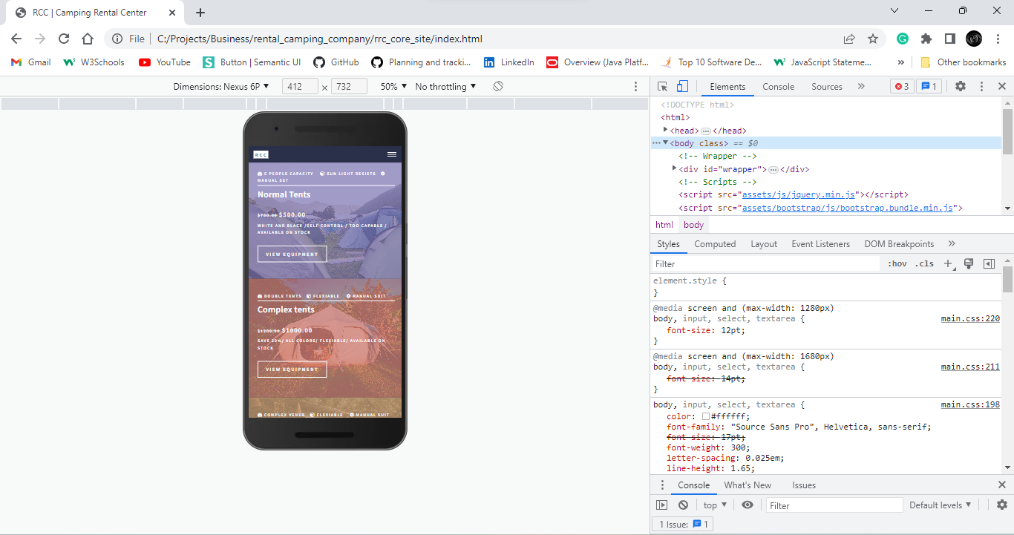

Figure 1.0 showing the responsiveness of the website up to (412 x 732).

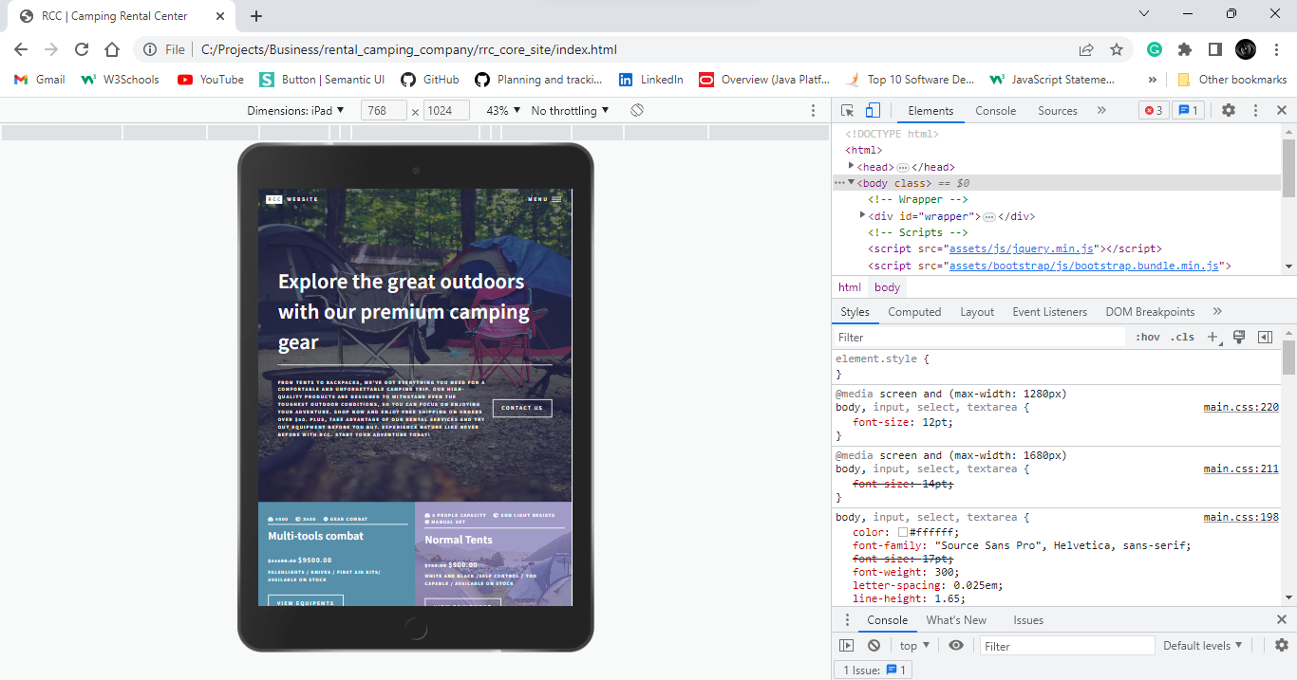

Figure 1.0 showing the responsiveness of the website up to (700 x 1024).

The website has the features that leads it to be viewed in such mobile devices and tablets and it meets the following criteria:

It has the content that inform the designed website in the way that it can attract customers, and explain more about the company`s vision, goal and motto.

Thereafter, the website developed contains the includes pictures which are relevant of company leisure equipment. On top of that the website include the homepage with Menu that contain the nav link of the Homepage, camping equipment (where one can search of the campaign, he\she wants at the reasonable campaign. And this page provides a catalogue of products that are on sale or rental.

After that, the website has the review page with responsive contact section where the team or a person can check the added to cart products and make the changes then purchase or rent the products.

Last but not least, all this pages that contain the images and text search packages have the responsive resize design that includes the plugins such JavaScript and Bootstrap.

Lastly, on the HTML structure of the website has been designed within the standard of W3C where by the naming, structure of building webpage has been followed.

During the development process of this project a have the external CSS files that have been used to provide the style of the website in a statical way. And each web page has been linked to this external CSS files in the way that the relevant features of CSS as border, box-shadow, animations, hover and many more react on this website efficiently.

## **Testing**

I have used the W3C validation service **(**[**http://Validator.w3.org/**](http://Validator.w3.org/)**)** to check and test the HTML and CSS code if is in the recommended way and if it follows the requirements. I have attempted to remove and recode as many non-compliant features and errors as possible and I have made sure that the non-error code has been saved and being used as a tool of this website.

On top of that, I have use also tested the website’s accessibility using a relevant screen reader in a GOOGLE CHROME web browser and I noted that the website is not fall from the correct screen reader due to the correctness on how the way HTML is hard coded in this project which follows the W3C standard.

Not only that, I have also tested the website in two different browsers to take a look on the responsiveness of this website. And these web browsers are **GOOLE** **CHROME** and **MICRSOFT** **EDGE**.

And I noted that the responsive of this website is not facing any impact just because the media queries have been hard-coded in a correctness way and high standard. Even this responsive have been indicated to the images embed in the website.

## **Evaluation**

### **Website Plugins**

Sure, I'd be happy to explain how JavaScript, Bootstrap, and CSS have been used to develop a website with a responsive design that includes plugins.

JavaScript is a programming language that is often used to add interactivity and dynamic functionality to websites. For example, JavaScript have been used to create image sliders, pop-up windows, and drop-down menus. With JavaScript, add these kinds of features to this website and make it more engaging and user-friendly.

Bootstrap is a front-end framework that makes it easier to create responsive designs for websites. A responsive design means that the website can adapt to different screen sizes, so it looks good on desktops, tablets, and smartphones. Bootstrap provides pre-designed templates and components that you can use to build a responsive website quickly and easily. For example, I have used Bootstrap's grid system to create a layout that automatically adjusts to different screen sizes.

CSS (Cascading Style Sheets) is a stylesheet language used to describe the presentation of a document written in HTML. It is used to control the layout, typography, and visual appearance of a website. CSS can be used to customize the styling of your website, including font sizes, colors, and backgrounds. With CSS, I also create media queries that specify how your website should look on different devices, based on their screen size.

Using JavaScript, Bootstrap, and CSS together, I have created a website with a responsive design that includes plugins.

### **Web application tools**

Sure, I'd be happy to evaluate HTML and CSS as web application development tools and explain how they have been used in website development.

HTML (Hypertext Markup Language) is the standard markup language used to create web pages. HTML is used to structure content on a web page, including headings, paragraphs, images, and links. HTML provides the basic building blocks for a website, and it is essential for creating a well-structured and organized site.

CSS (Cascading Style Sheets) is a stylesheet language used to describe the presentation of a document written in HTML. CSS is used to control the layout, typography, and visual appearance of a website. With CSS, you can customize the styling of your website, including font sizes, colors, and backgrounds.

Both HTML and CSS are essential web development tools, and they have been used in website development in various ways. Here are some examples:

Structuring Content: HTML is used to create the structure of a web page, including headings, paragraphs, lists, and tables. This helps organize the content and make it easier to read and understand.

Styling Content: CSS is used to style the content on a web page, including the fonts, colors, and backgrounds. This helps create a visually appealing website that is easy to read and navigate.

Responsive Design: CSS is also used to create a responsive design, which allows the website to adapt to different screen sizes, such as desktops, tablets, and smartphones.

Interactivity: HTML and CSS can be used together with JavaScript to create interactive elements on a web page, such as buttons, forms, and pop-ups.

Overall, HTML and CSS are fundamental web development tools that are used extensively in website development. They provide the basic building blocks for creating a well-structured and visually appealing website that is easy to navigate and use.

### **Benefits of using web to RCC**

Two potential business benefits to RCC of using web services:

* Improved Integration: By using web services, RCC can better integrate its different systems and applications, making it easier to share data and information across the organization. For example, if RCC uses a web service to manage its inventory, that information can be easily shared with its e-commerce platform, allowing customers to see real-time availability of products and ensuring that inventory levels are accurately reflected across all channels.
* Enhanced Scalability: Web services can help RCC to more easily scale its operations as the business grows. For example, if RCC expands to new geographic regions, it can use web services to quickly add new payment processors or shipping providers to its e-commerce platform, without having to build and maintain custom integrations. This can save RCC time and money, while also helping to ensure a seamless customer experience.

Overall, by leveraging web services, RCC can gain more flexibility, agility, and efficiency in its operations, ultimately helping to drive growth and profitability for the business

### **Recommended improvements**

Here are some recommendations for further developing RCC's website in line with the business objectives for growth:

* Improve the User Experience: One key area for improvement is the website's user experience (UX). RCC should focus on making the website more user-friendly and intuitive to navigate, with clear calls-to-action that guide visitors towards making a purchase. This can include improving the site's search functionality, simplifying the checkout process, and optimizing the site for mobile devices.
* Increase Personalization: Another area for improvement is personalization. RCC can use data analytics and customer insights to create more personalized experiences for its website visitors. This can include offering personalized product recommendations based on a visitor's browsing and purchase history, or tailoring marketing messages based on geographic location or other demographic factors.
* Expand Product Offerings: RCC can also work to expand its product offerings, both by adding new categories of products and by increasing the variety of products within existing categories. This can help to attract new customers and increase sales from existing customers. RCC should also consider partnering with other brands and retailers to offer a wider selection of products on its site.
* Enhance Digital Marketing Efforts: Finally, RCC should focus on enhancing its digital marketing efforts to drive more traffic to the website and increase brand awareness. This can include investing in search engine optimization (SEO), paid search and social media advertising, and email marketing campaigns. By improving its digital marketing, RCC can reach more potential customers and increase sales through its website.

By implementing these recommendations, RCC can continue to grow its online presence and drive sales through its website, ultimately helping to achieve its business objectives for growth.

**Conclusion**

In conclusion, this assignment has focused on the fictional company RCC, a retail camping company, and provided various recommendations and solutions to help the business achieve its growth objectives. Throughout this assignment, we have discussed the importance of implementing web services, optimizing the website's user experience, expanding product offerings, and enhancing digital marketing efforts. By implementing these strategies, RCC can improve its operations, better serve its customers, and ultimately drive growth and profitability for the business.

Furthermore, this assignment has highlighted the importance of leveraging technology and data analytics to gain insights and make informed business decisions. By using technology to streamline processes and gain a better understanding of customer behavior, RCC can more effectively target its marketing efforts, optimize its inventory management, and enhance its overall business performance.

Overall, this assignment has emphasized the need for businesses to adapt and evolve in response to changing market conditions and customer preferences. By staying agile and adopting a customer-centric approach, businesses like RCC can not only survive but thrive in today's fast-paced and competitive business landscape